Media Player Playlist Enhancement:
- Users should be able to add songs to the media player playlist with options to "play now", "play next", or "play last". An optional button for "add all songs" will also be included.
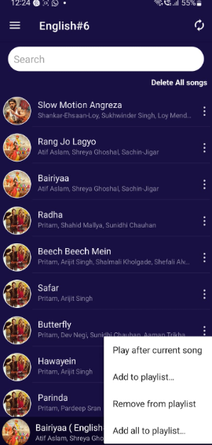
- Delete playlist" will be removed from the "my playlist" option.
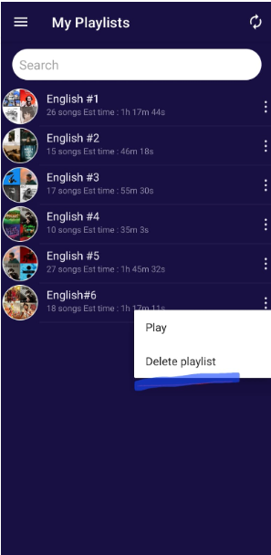

- "Delete all song" will be removed from a particular playlist.
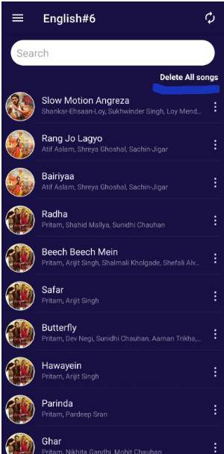

- Delete all song" functionality will be added to the media player playlist.
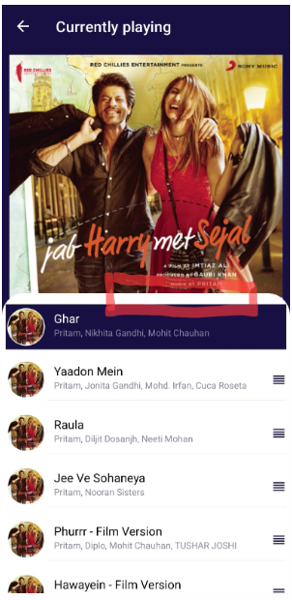

- Estimated time for the media player playlist will be displayed in the media player..
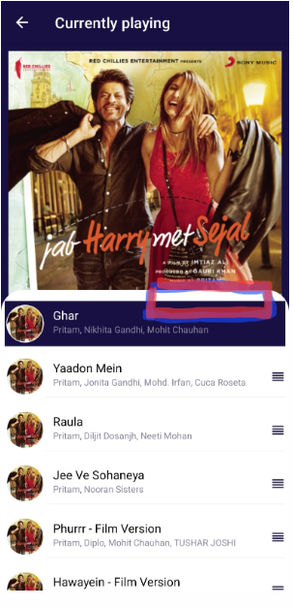
Song History Management:
- Once a song finish playing from the media player playlist, it will be automatically moved to the history page.
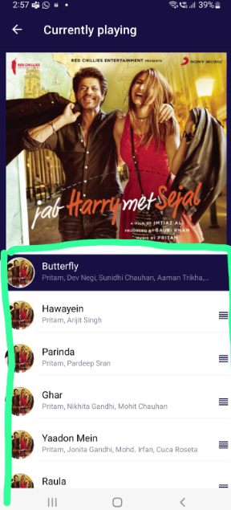

- The history page will feature the same functionality as the media player playlist: "play now", "play next", and "play last".
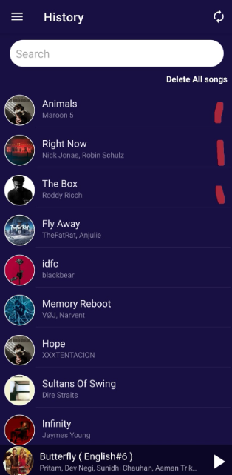
User Interface Enhancements:
- The media player icon will remain visible even if no song is currently playing. (Needs to check feasibility with development team)
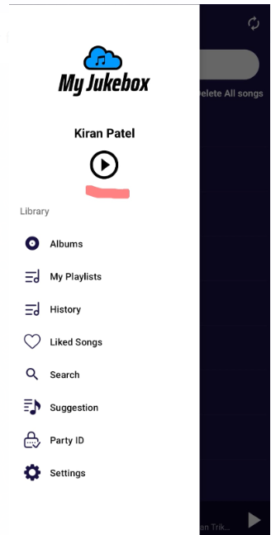
- The previous button will be retained in the media player to allow users to retrieve songs from the history page. (Needs to check feasibility with development team)
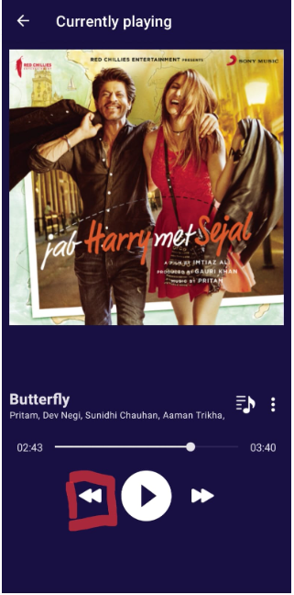
- The media player icon will be updated based on your suggestions. You will provide reference for the desired changes.

